Basic Command of Oracle Database

select * from user_tables

create sequence seq start with 1 increment by 1

select seq.nextval from dual

select seq.currval from dual

desc dept

select * from emp inner join dept on emp.deptno=dept.deptno and dept.loc='DALLAS' and emp.sal>2000

create table mystudent ( id varchar2(20) primary key, name varchar2(20), dob date)

select * from mystudent

insert into mystudent(id) values(1)

insert into mystudent values(2, 'sujeet', '04-30-195')

update mystudent set dob='04/30/1995' where id='2'

update mystudent set dob='04/30/1995' where id='2'

alter table mystudent add age number(5)

alter table mystudent add constraint age_check check (age>0 and age<=100)

update mystudent set age=20 where id = '2'

update mystudent set age=120 where id = '2'

create table students ( sid number(10) primary key, name varchar2(20))

select * from students

create table employee(id number(10) primary key, name varchar2(20), doj date, address varchar2(30), email varchar2(30), salary number(10), age number(5) check (age between 1 and 100) enable)

--DEU6

create table job_department(deptid number(10) primary key, departmentname varchar2(20))

select * from job_department

update job_department set departmentname='development'

create sequence seq_depart_id minvalue 1 start with 1 increment by 1

select seq_depart_id from dual

create table jobseeker(email varchar2(20) primary key, firstname varchar2(20), lastname varchar2(20), contact_no number(10), yearofpassing number(5), experience number(4), qualification varchar2(20), did number(5) references job_department(deptid), skill varchar2(30))

drop table jobseeker

create sequence seq_jobskr_id minvalue 1 start with 1 increment by 1

select seq_jobskr_id from dual

select * from jobseeker

insert into jobseeker values('sujeet@gmail.com', 'sujeet', 'kumar', 9971879231, 2018, 2, 'btech', 1, 'java')

--SQL paper solution

create table department(departmentid number(10) primary key, departmentname varchar2(20))

drop table deptment

insert into department values(1, 'EEE')

insert into department values(2,'ECE')

insert into department values(3, 'EI')

insert into department values(4, 'CSE')

insert into department values(5, 'IT')

select * from department

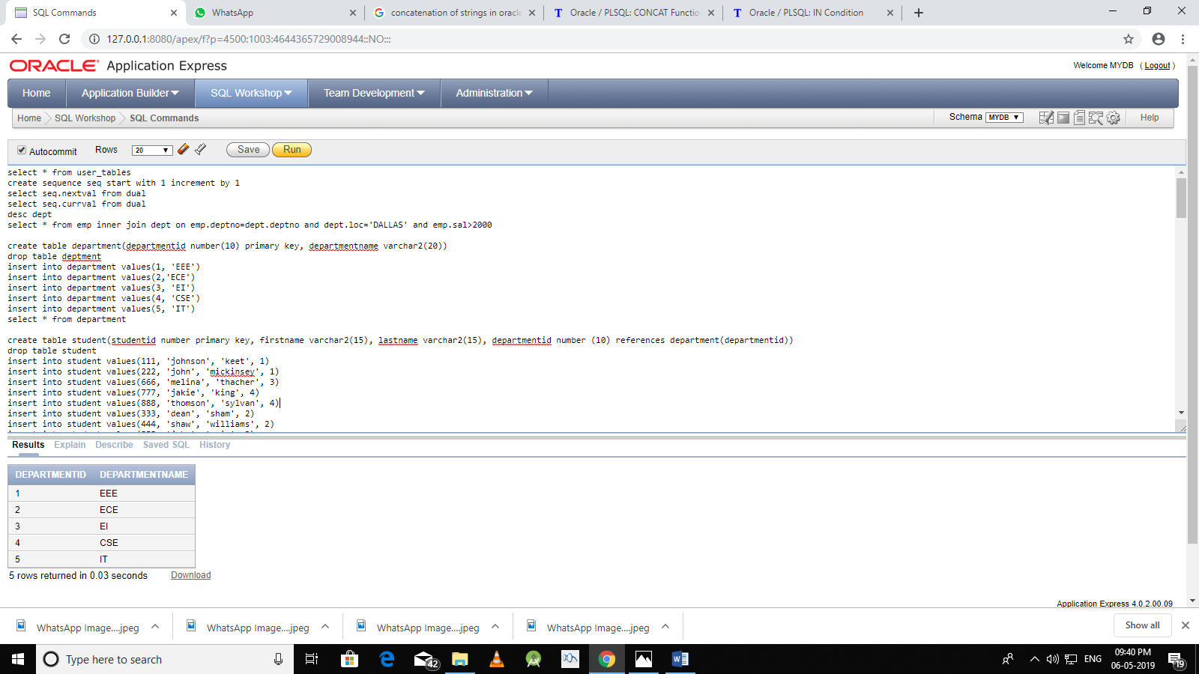

create table student(studentid number primary key, firstname varchar2(15), lastname varchar2(15), departmentid number (10) references department(departmentid))

drop table student

insert into student values(111, 'johnson', 'keet', 1)

insert into student values(222, 'john', 'mickinsey', 1)

insert into student values(666, 'melina', 'thacher', 3)

insert into student values(777, 'jakie', 'king', 4)

insert into student values(888, 'thomson', 'sylvan', 4)

insert into student values(333, 'dean', 'sham', 2)

insert into student values(444, 'shaw', 'williams', 2)

insert into student values(555, 'john', 'cain', 3)

insert into student values(999, 'peter', 'stain', 5)

insert into student values(1000, 'jack', 'kali', 5)

insert into student(studentid, firstname, lastname) values(1011, 'amy', 'jack')

select * from student

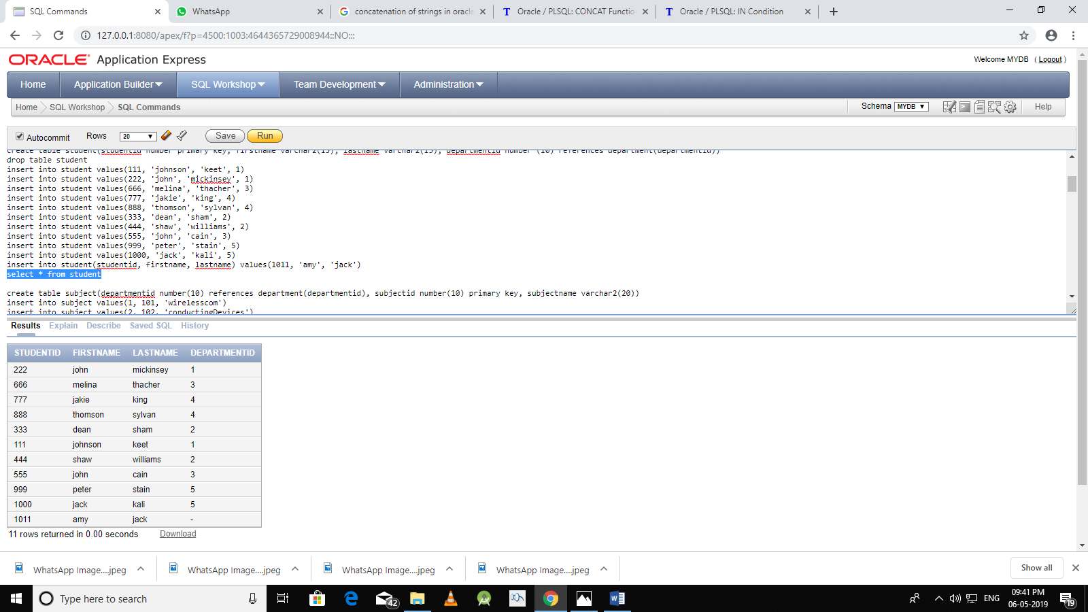

create table subject(departmentid number(10) references department(departmentid), subjectid number(10) primary key, subjectname varchar2(20))

insert into subject values(1, 101, 'wirelesscom')

insert into subject values(2, 102, 'conductingDevices')

insert into subject values(4, 103, 'instrument')

insert into subject values(3, 104, 'java')

insert into subject values(5, 105, 'webtechnology')

insert into subject values(5, 106, 'scripts')

select * from subject

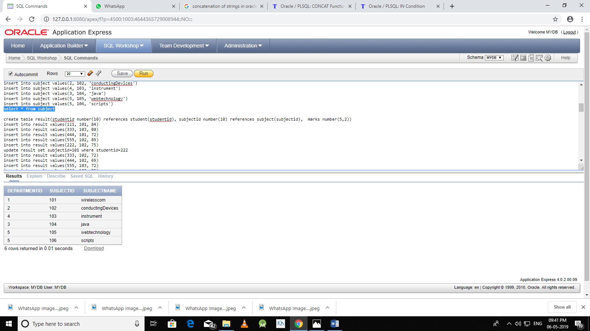

create table result(studentid number(10) references student(studentid), subjectid number(10) references subject(subjectid), marks number(5,2))

insert into result values(111, 101, 84)

insert into result values(333, 103, 80)

insert into result values(444, 101, 72)

insert into result values(555, 102, 89)

insert into result values(222, 102, 75)

update result set subjectid=101 where studentid=222

insert into result values(333, 102, 72)

insert into result values(444, 102, 69)

insert into result values(555, 103, 72)

insert into result values(666, 103, 89)

insert into result values(777, 104, 55)

insert into result values(888, 104, 65)

insert into result values(999, 105, 59)

insert into result values(1000, 105, 81)

insert into result values(111, 104, 61)

insert into result values(222, 102, 59)

select * from result

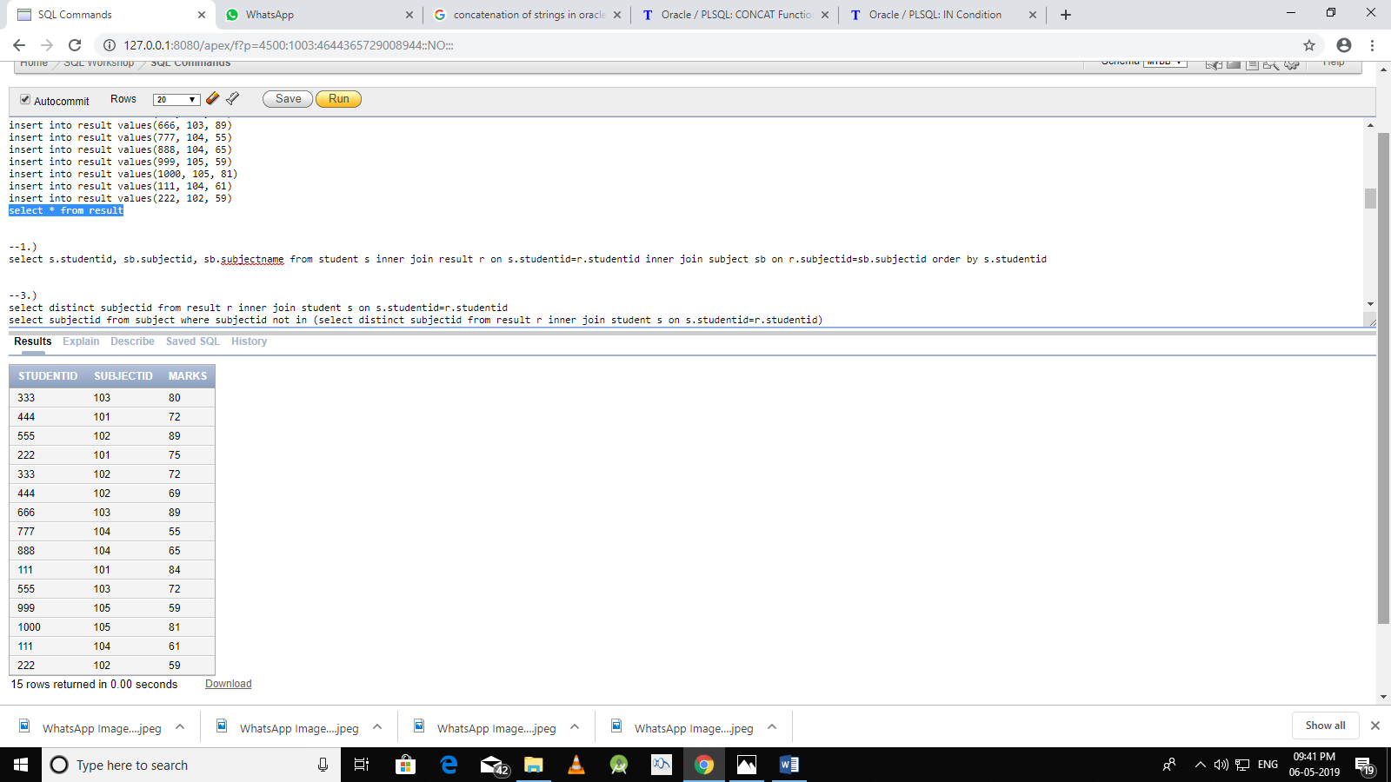

--1.)

select s.studentid, sb.subjectid, sb.subjectname from student s inner join result r on s.studentid=r.studentid inner join subject sb on r.subjectid=sb.subjectid order by s.studentid

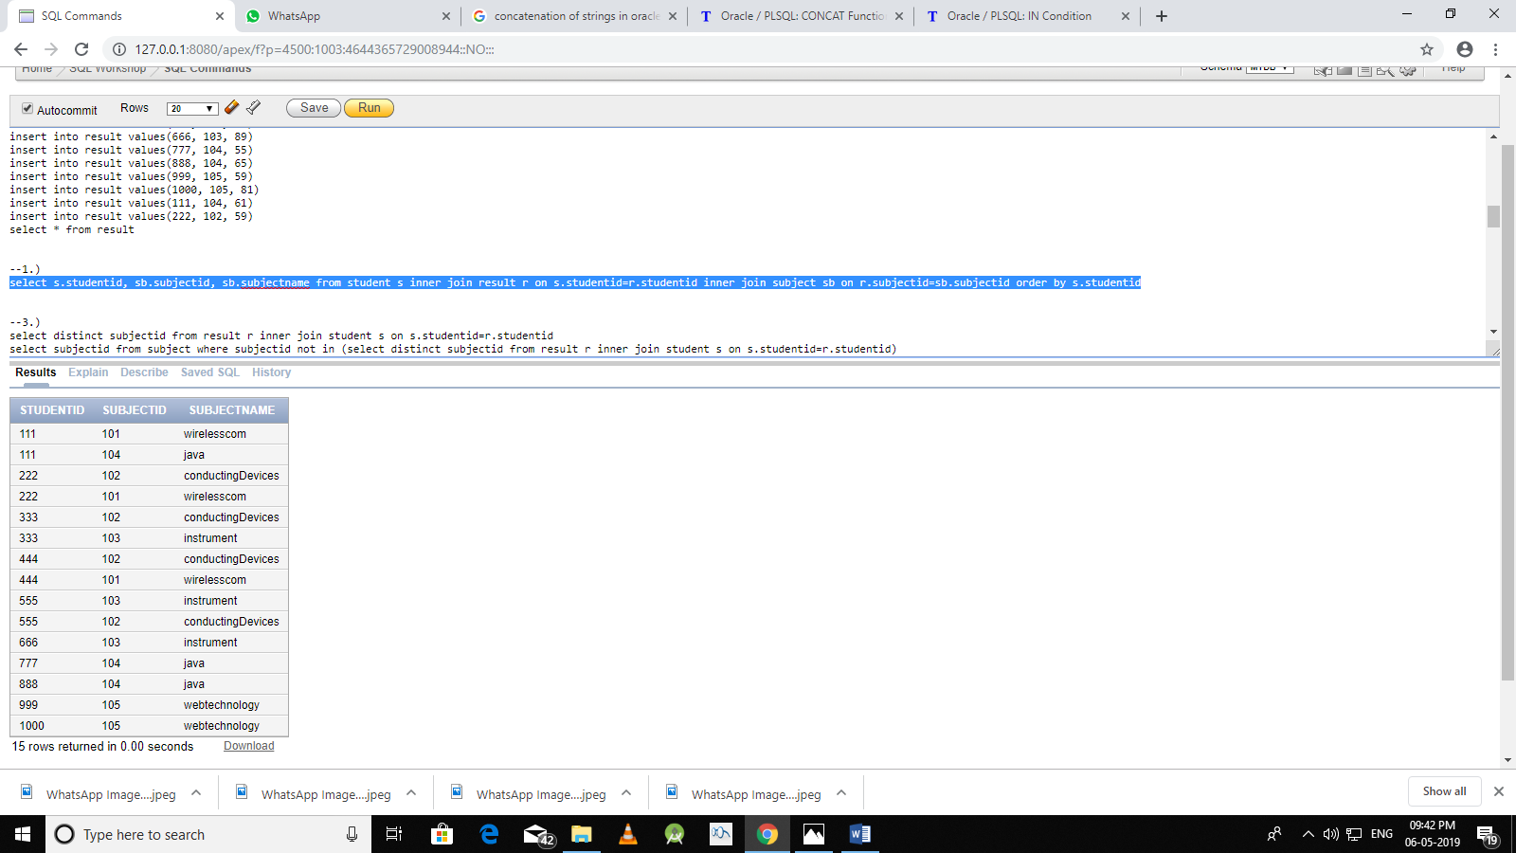

--2.)

select sb.subjectname, d.departmentid, decode(d.departmentname, 'EEE', 'Electrical & Electronics Engg', 'ECE', 'Electrical & Communication Engg', 'EI', 'Electronics & Instrumentation', 'CSE', 'Computer Science Engg', 'IT', 'Infomation Technology') from subject sb inner join department d on sb.departmentid=d.departmentid

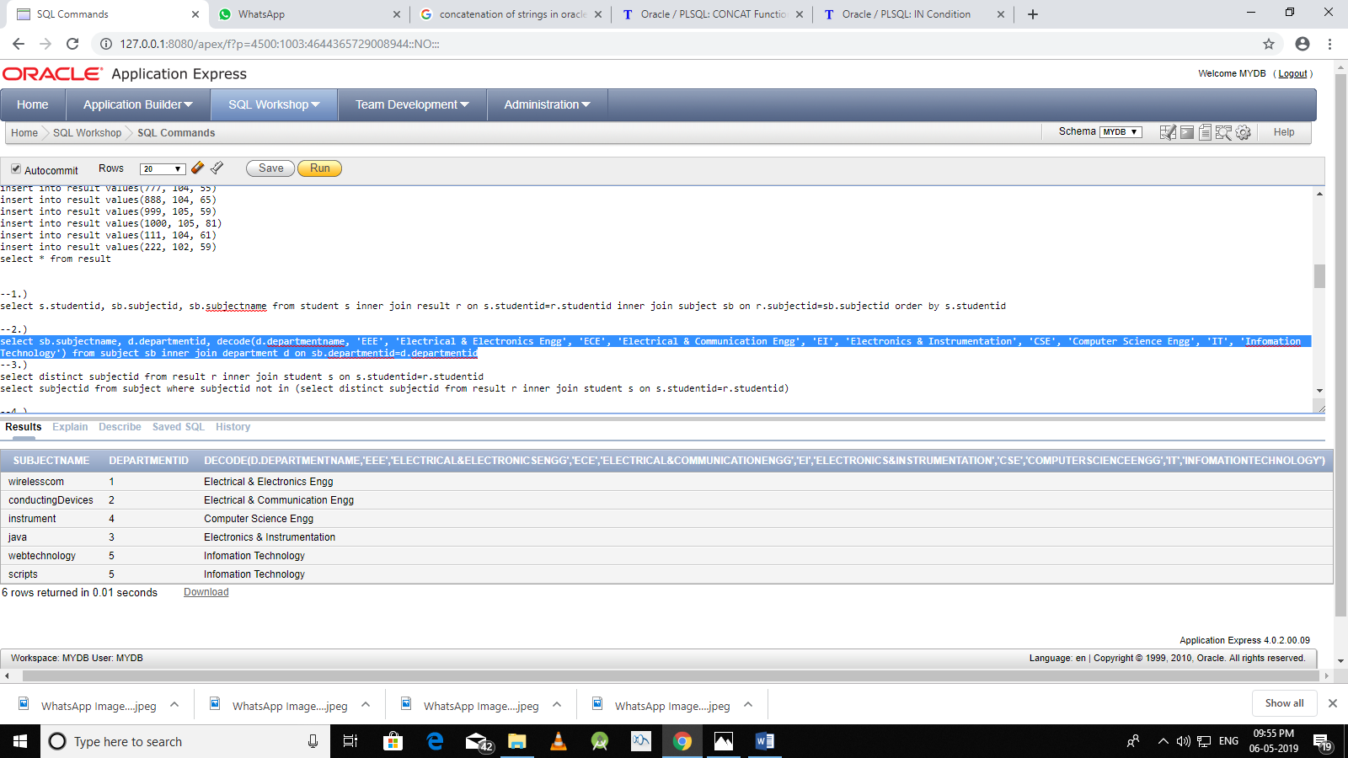

--3.)

--select distinct subjectid from result r inner join student s on s.studentid=r.studentid

select subjectid from subject where subjectid not in (select distinct subjectid from result r inner join student s on s.studentid=r.studentid)

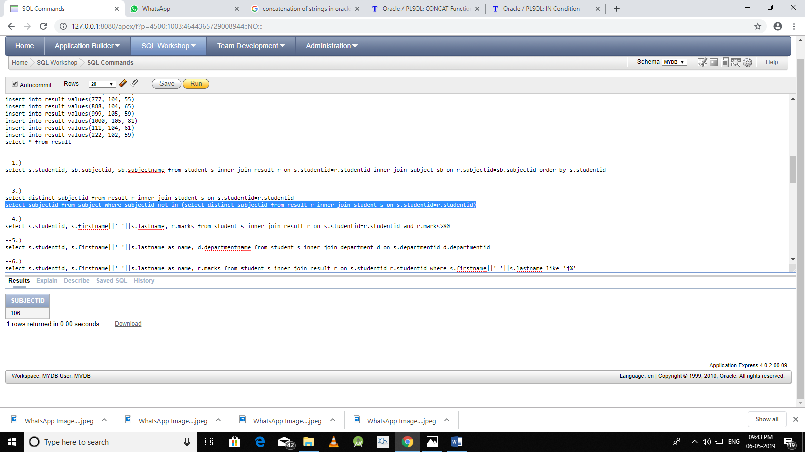

--4.)

select s.studentid, s.firstname||' '||s.lastname, r.marks from student s inner join result r on s.studentid=r.studentid and r.marks>80

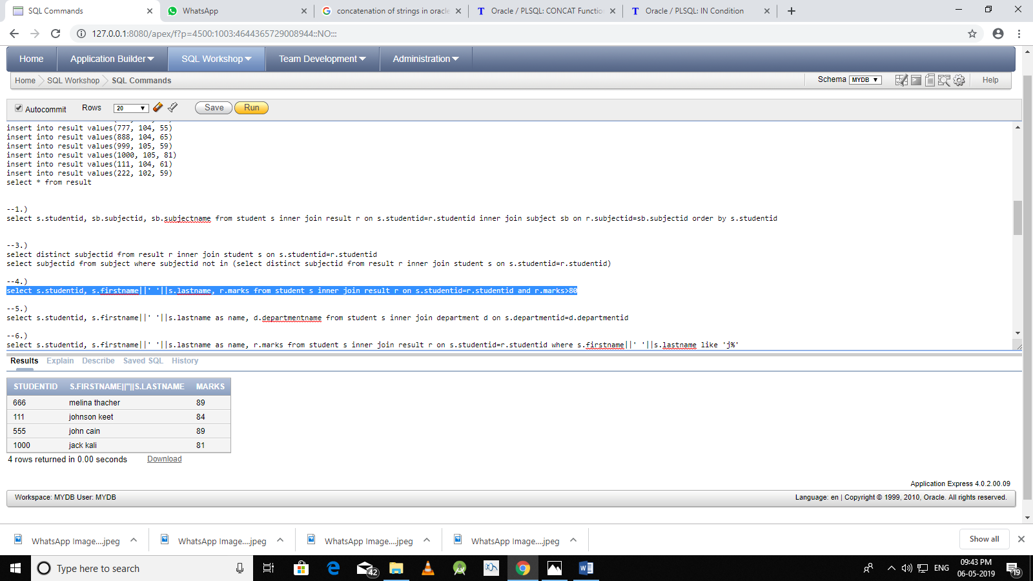

--5.)

select s.studentid, s.firstname||' '||s.lastname as name, d.departmentname from student s inner join department d on s.departmentid=d.departmentid

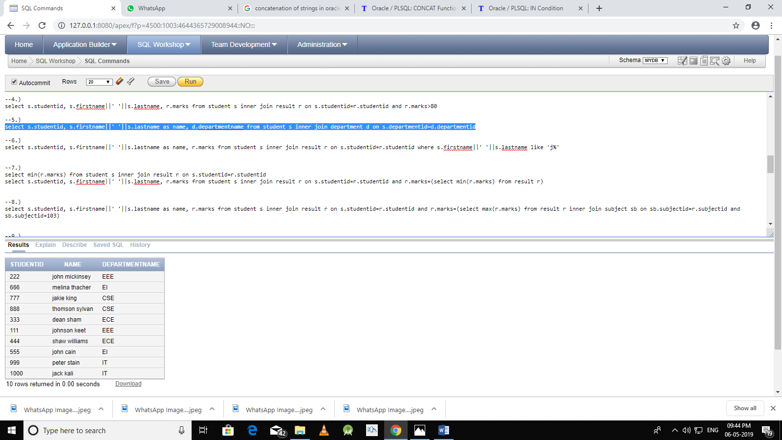

--6.)

select s.studentid, s.firstname||' '||s.lastname as name, r.marks from student s inner join result r on s.studentid=r.studentid where s.firstname||' '||s.lastname like 'j%'

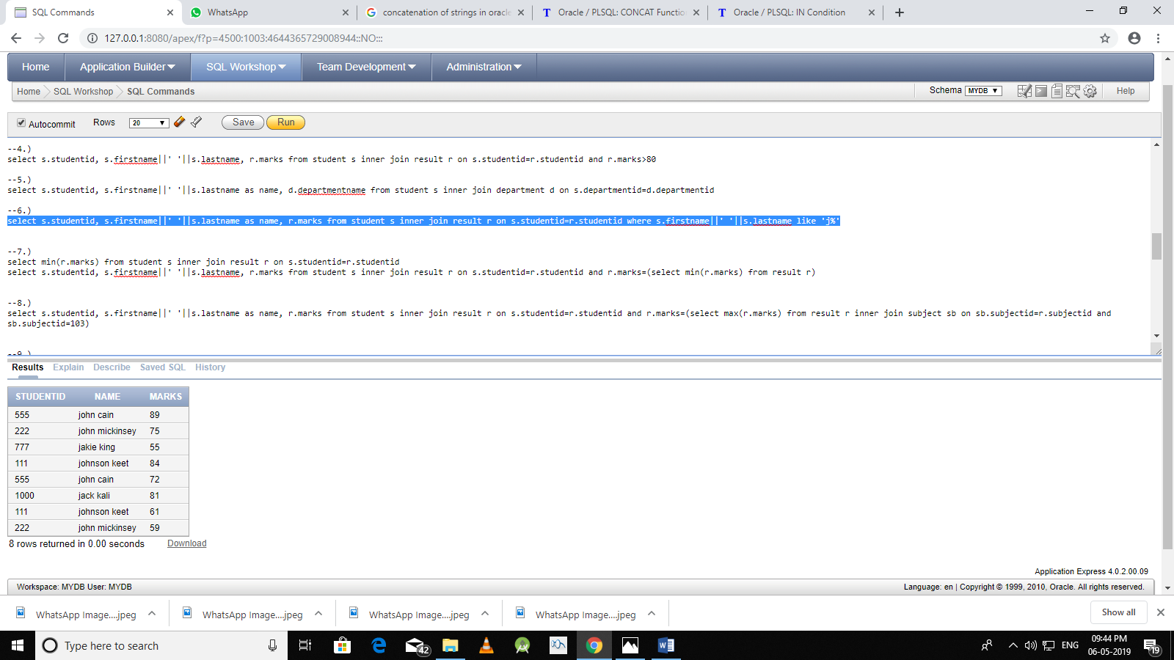

--7.)

select min(r.marks) from student s inner join result r on s.studentid=r.studentid

select s.studentid, s.firstname||' '||s.lastname, r.marks from student s inner join result r on s.studentid=r.studentid and r.marks=(select min(r.marks) from result r)

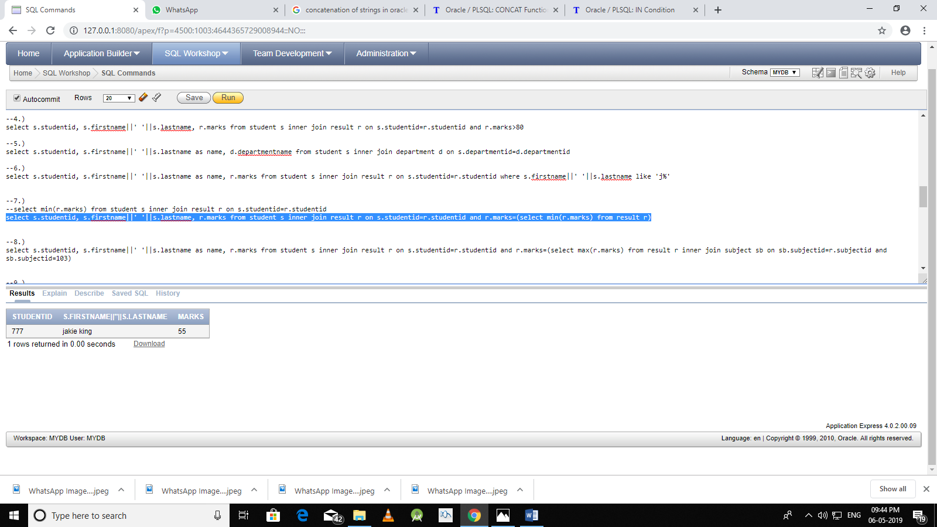

--8.)

select s.studentid, s.firstname||' '||s.lastname as name, r.marks from student s inner join result r on s.studentid=r.studentid and r.marks=(select max(r.marks) from result r inner join subject sb on sb.subjectid=r.subjectid and sb.subjectid=103)

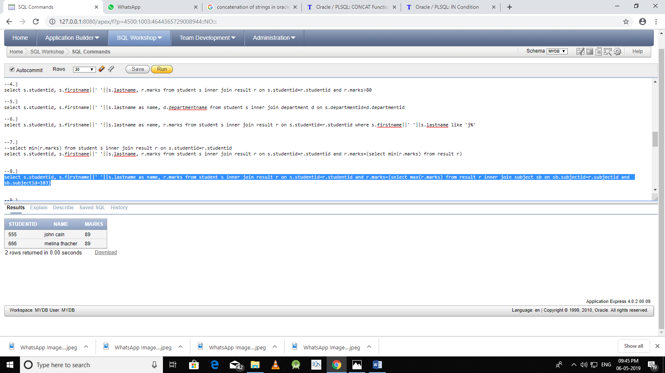

--9.)

select min(r.marks), max(r.marks) from result r group by subjectid

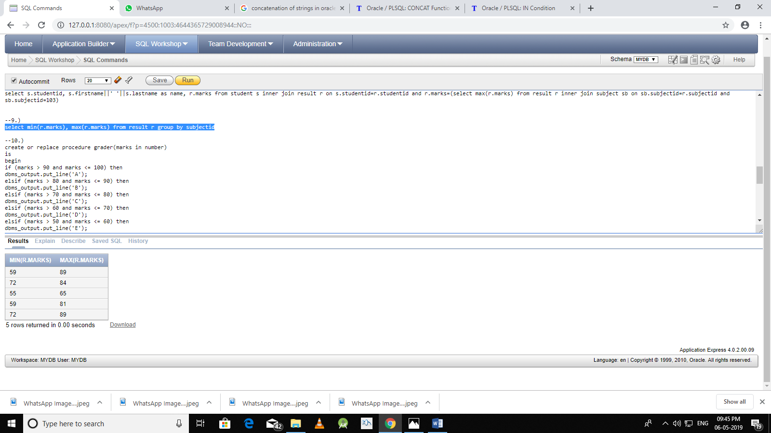

--10.)

create or replace procedure grader(marks in number)

is

begin

if (marks > 90 and marks <= 100) then

dbms_output.put_line('A');

elsif (marks > 80 and marks <= 90) then

dbms_output.put_line('B');

elsif (marks > 70 and marks <= 80) then

dbms_output.put_line('C');

elsif (marks > 60 and marks <= 70) then

dbms_output.put_line('D');

elsif (marks > 50 and marks <= 60) then

dbms_output.put_line('E');

else

dbms_output.put_line('F');

end if;

end;

declare

begin

grader(87);

end;

--function

create or replace function graderfun(marks in number)

return char

is

grade char :='F';

begin

if (marks > 90 and marks <= 100) then

grade:='A';

return grade;

elsif (marks > 80 and marks <= 90) then

grade:='B';

return grade;

elsif (marks > 70 and marks <= 80) then

grade:='C';

return grade;

elsif (marks > 60 and marks <= 70) then

grade:='D';

return grade;

elsif (marks > 50 and marks <= 60) then

grade:='E';

return grade;

else

grade:='F';

return grade;

end if;

end;

select graderfun(r.marks) from result r inner join student s on s.studentid=r.studentid

